- Download a sample food delivery dataset (orders, restaurant names, order dates, total amount) and create a Pivot Table to summarize total sales per restaurant.
ANSWERS:
Row Labels | Sum of Total Amount
Gordhan Thal | 3500
Havmor Restaurant | 1630
Honest Restaurant | 2250
Swati Snacks | 1350
Grand Total | 8730

- Using the Pivot Table from your food delivery dataset, insert a Pivot Chart as a Bar Chart to visually compare total sales of each restaurant. Apply a custom color scheme to make the chart more readable.
ANSWERS:

- Add a Slicer to your Pivot Table and Chart that lets you filter sales data by month, so you can see how each restaurant performed in different months.
ANSWERS:
Sum of Total Amount | Column Labels
Row Labels | Aug | Sep | Oct | Grand Total
Gordhan Thal | 1850 | 2200 | 3500 | 7550
Havmor Restaurant | 920 | 810 | 740 | 2470
Honest Restaurant | 1200 | 1450 | 1770 | 4420
Swati Snacks | 650 | 480 | 900 | 2030
Grand Total | 4620 | 4940 | 6910 | 16470

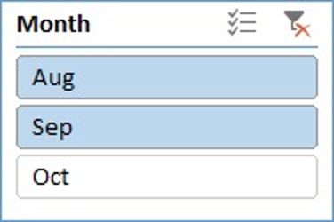
- Switch your Pivot Chart to a Pie Chart to show the percentage share of total sales for each restaurant, and format the chart to display data labels with both value and percentage.
Hint: Right-click the chart to add data labels, then adjust label options.
ANSWERS:

- Create an interactive dashboard sheet that displays a Line Chart from your Pivot Table showing monthly sales trends for the top 3 restaurants, and design the dashboard layout to look clean and user-friendly (add a title, adjust fonts, and align elements).
ANSWERS:

